St. Andrew’s Hespeler Presbyterian Church
73 Queen Street East,
Cambridge, ON N3C 2A9
519-658-2652
Rev. Scott McAndless: smcandless@standrewshespeler.ca
Email: office@standrewshespeler.ca
Prayer Requests: prayerchain@standrewshespeler.ca
Website: www.standrewshespeler.ca
Office Hours:
The office is currently closed.

St. Andrew’s Hespeler
Presbyterian Church
April 19, 2020
2nd Sunday of Easter

Order of Online Worship for April 19, 2020
We will meet online for as long as people want to stay on at 10 am on Sunday, April 19. The link will be posted on the Website and FaceBook page.
Call to worship
Leader: All you works of God, all you mighty heavens,
All: Worship and praise your Maker.
Leader: Sun, moon and stars; wind, rain and thunder,
All: Worship and praise your Maker.
Leader: Mountains and forests, streams and waterfalls,
All: Worship and praise your Maker.
Leader: Whales beneath the seas, birds throughout the skies,
All that leaps or crawls, all folk who worry and wonder,
All: Let us worship and praise our Maker together.
Prayers of confession
Responsive Psalm 16 (Microphones on)

Psalm 16
L: ¹ Protect me, O God, for in you I take refuge.
P: ² I say to the Lord, “You are my Lord;
I have no good apart from you.”
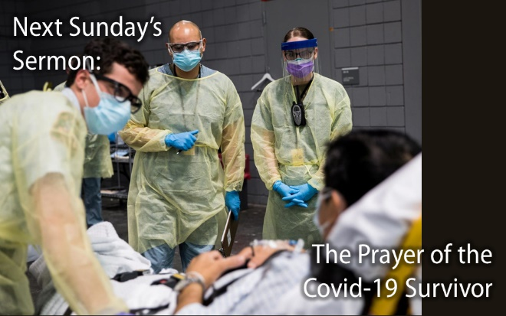
L: As for the holy ones in the land, they are the noble,
in whom is all my delight.
P: ⁴ Those who choose another god multiply their sorrows;
their drink offerings of blood I will not pour out
or take their names upon my lips.
L: The Lord is my chosen portion and my cup;
you hold my lot.
P: ⁶ The boundary lines have fallen for me in
pleasant places;
I have a goodly heritage.
L: I bless the Lord who gives me counsel;
in the night also my heart instructs me.
⁸ I keep the Lord always before me;
P: because he is at my right hand, I shall not be moved.
⁹ Therefore my heart is glad, and my soul rejoices;
my body also rests secure.
L: For you do not give me up to Sheol,
or let your faithful one see the Pit.
P: You show me the path of life.
In your presence there is fullness of joy;
in your right hand are pleasures forevermore.
Ongoing life of the church
John 20:19-31 (see below)
Celebration of our Generosity
Prayers of the people (using chat to share requests)
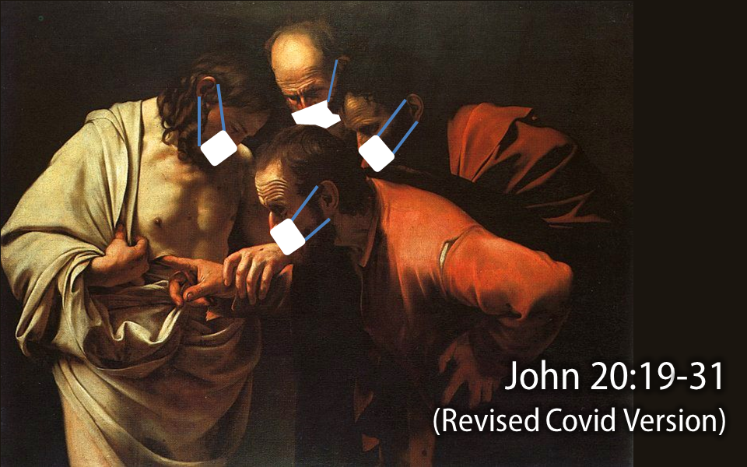
Benediction *Feel free to chat for a while.
Sermon: Rev. Scott will preach a live sermon over Zoom for those who wish to stay for it. The sermon will also have already been posted on YouTube for streaming whenever you like. The YouTube sermon may have better video and/or audio quality and will feature some graphic illustrations. It will otherwise be the same sermon. The sermon title is:

Prayer Partnership

Sunday, April 19 We pray for those in our circle of friendship and love who need healing, guidance or strength.

Monday, April 20 We thank God for the Cyclical PCC coaches. Guide and encourage them as they work with leaders discerning calls to new ministry.

Tuesday, April 21 We give thanks for Presbyterian World Service & Development partners who are helping marginalized farmers protect and revitalize the soil and cultivate plentiful harvests.

Wednesday, April 22 (Earth Day) We give thanks for this earth that God has made. Today, on the 50th anniversary of Earth Day, we pray for the will to make the hard changes required to fulfill our responsibilities as wise and faithful stewards of creation.

Thursday, April 23 We pray for the continued efforts of individuals and communities in responding to the Truth and Reconciliation Commission’s 94 Calls to Action, which were released in 2015.

Friday, April 24 We pray for guidance for the members of the Women’s Missionary Society Council Executive as they make decisions that will allow them to continue their ministry into the future.

Saturday, April 25 We pray for the Vancouver School of Theology’s search for a new Academic Dean
Please Note: All church activities have been suspended until further notice. If you have questions or concerns, or if we can support you in any way, please contact us by calling the church (messages are checked regularly) or email us at office@standrewshespeler.ca. We care about you! You are not alone!
April 19: Earth Day (April 22)
Lucsius knows that when he cares for the earth he can take better care of his family. Having discovered conservation agriculture, soil care management and crop diversification through a PWS&D-supported program, this Haitian farmer now grows a diverse range of food. The legumes, cassava, cabbage, peppers, carrots, beans, potatoes and bananas help make his family’s meals both colourful and nutritious. Excited for his increased ability to provide for his family, Lucsius saved the profits from selling his vegetables to buy a pig, further improving his family’s food security. Reflecting on the support he received from PWS&D and other farmers in his community, Lucsius said, “It is possible to produce better food to be able to feed our families.”
PWS&D supports small-scale farmers.
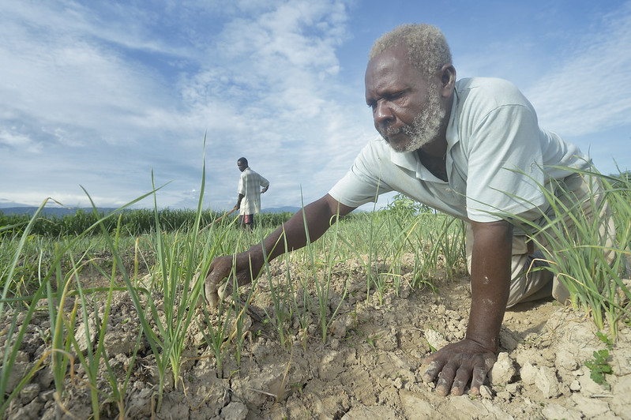
Lectionary Readings for April 19

Acts 2:14a, 22-32
¹⁴ But Peter, standing with the eleven, raised his voice and addressed them,
²² “You that are Israelites, listen to what I have to say: Jesus of Nazareth, a man attested to you by God with deeds of power, wonders, and signs that God did through him among you, as you yourselves know – ²³ this man, handed over to you according to the definite plan and foreknowledge of God, you crucified and killed by the hands of those outside the law. ²⁴ But God raised him up, having freed him from death, because it was impossible for him to be held in its power. ²⁵ For David says concerning him,
‘I saw the Lord always before me, for he is at my right hand so that I will not be shaken; ²⁶ therefore my heart was glad, and my tongue rejoiced; moreover my flesh will live in hope. ²⁷ For you will not abandon my soul to Hades, or let your Holy One experience corruption. ²⁸ You have made known to me the ways of life; you will make me full of gladness with your presence.’
²⁹ “Fellow Israelites, I may say to you confidently of our ancestor David that he both died and was buried, and his tomb is with us to this day. ³⁰ Since he was a prophet, he knew that God had sworn with an oath to him that he would put one of his descendants on his throne. ³¹ Foreseeing this, David spoke of the resurrection of the Messiah, saying, ‘He was not abandoned to Hades, nor did his flesh experience corruption.’ ³² This Jesus God raised up, and of that all of us are witnesses.

1 Peter 1:3-9
³ Blessed be the God and Father of our Lord Jesus Christ! By his great mercy he has given us a new birth into a living hope through the resurrection of Jesus Christ from the dead, ⁴ and into an inheritance that is imperishable, undefiled, and unfading, kept in heaven for you, ⁵ who are being protected by the power of God through faith for a salvation ready to be revealed in the last time. ⁶ In this you rejoice, even if now for a little while you have had to suffer various trials, ⁷ so that the genuineness of your faith– being more precious than gold that, though perishable, is tested by fire– may be found to result in praise and glory and honor when Jesus Christ is revealed. ⁸ Although you have not seen him, you love him; and even though you do not see him now, you believe in him and rejoice with an indescribable and glorious joy, ⁹ for you are receiving the outcome of your faith, the salvation of your souls.

John 20:19-31
¹⁹ When it was evening on that day, the first day of the week, and the doors of the house where the disciples had met were locked for fear of the Jews, Jesus came and stood among them and said, “Peace be with you.” ²⁰ After he said this, he showed them his hands and his side. Then the disciples rejoiced when they saw the Lord. ²¹ Jesus said to them again, “Peace be with you. As the Father has sent me, so I send you.” ²² When he had said this, he breathed on them and said to them, “Receive the Holy Spirit. ²³ If you forgive the sins of any, they are forgiven them; if you retain the sins of any, they are retained.”
²⁴ But Thomas (who was called the Twin), one of the twelve, was not with them when Jesus came. ²⁵ So the other disciples told him, “We have seen the Lord.” But he said to them, “Unless I see the mark of the nails in his hands, and put my finger in the mark of the nails and my hand in his side, I will not believe.”
²⁶ A week later his disciples were again in the house, and Thomas was with them. Although the doors were shut, Jesus came and stood among them and said, “Peace be with you.” ²⁷ Then he said to Thomas, “Put your finger here and see my hands. Reach out your hand and put it in my side. Do not doubt but believe.” ²⁸ Thomas answered him, “My Lord and my God!” ²⁹ Jesus said to him, “Have you believed because you have seen me? Blessed are those who have not seen and yet have come to believe.”
³⁰ Now Jesus did many other signs in the presence of his disciples, which are not written in this book. ³¹ But these are written so that you may come to believe that Jesus is the Messiah, the Son of God, and that through believing you may have life in his name.
Here's our next Sunday School project:
Do you know that there are many people in our community who do not have enough food?. Now, more than ever, there are people who can't afford to buy food for their family. The Cambridge Self-Help Foodbank needs help serving the growing needs of people in our community. At this time they can only take money (to be safe)
donations.

Here's your project:
*start a journal and at least once a week, write out or draw what you are grateful for. We have much to be grateful for! If you would like to share with me (jsmith@standrewshespeler.ca) I would love to post on social media so that we can be an example to other people!

*start a food basket or box and once a week put an item of food in it. When we can safely get back together, at church,
we will bring in all of our baskets of food and donate them to the Cambridge Self-Help FoodBank.

*challenge your friends, cousins, neighbours to do the same
and donate the collected food to the food bank in their own
community.

